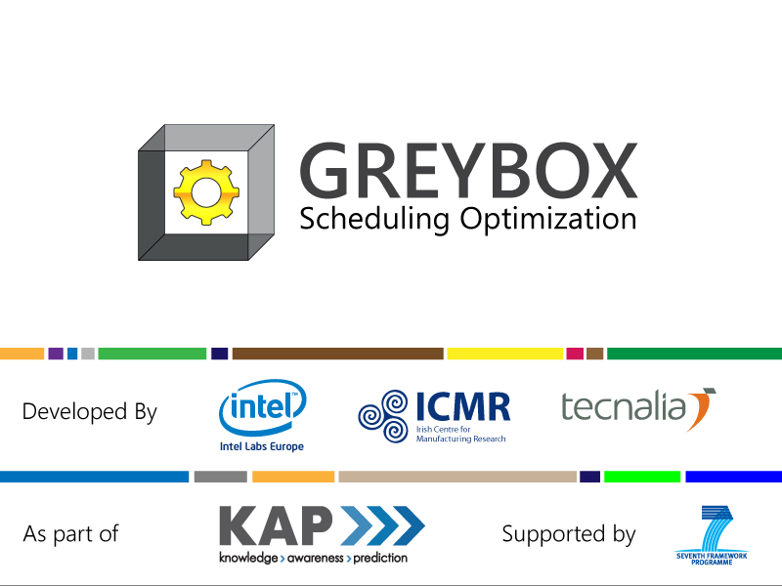
User Guide Version 1

Author: Connor Upton conor.upton@intel.com
Date: 08/11/2013

Contents
Introduction 3
What is it? 3
What can it be used for 3
User-Interface 3
Planning Screens 3
Tabs 4
Toolbar 5
Schedule Information Panel 6
Runplan – Resources View 7
Move an activity state 8
Resize an activity state 9
Change an activity state 9
Insert an activity state 9
Use-case Scenarios 10
Scenario 1: 11
Scenario 2: 11
Scenario 3: 12
Scenario 4: 12
Appendix 1 - Rules Configuration 14

Introduction

What is it?
The GREYBOX system is a set of interactive, web-based visualizations that can be used to inspect and adjust the relationships between time, tasks and outputs across a set of resources in a schedule. The system has the following capabilities
- allows you to observe past, current and future inventory and resource capacity
- supports planning, configuration, maintenance across your resources
- allows interaction such that you can edit & save schedules
- suggests an optimized schedule based on a range of input parameters

What can it be used for
The system was originally designed around manufacturing scheduling but it can be used in any scenario where you have
- A large set of configurable resources
- A set of output targets
- A set of goal and constraints relating to these targets
- A defined time period for targets to be met
Other potential use-cases outside of manufacturing include:
- Human resource scheduling
- Monitoring compute resources in a data center/distributed compute environment
- Device configuration for home energy management

User-Interface

Planning Screens
The planning screen is used to develop, refine and monitor schedules before and while they are executing. The GREYBOX planning interface has been designed to work with an optimization engine that can generate and amend future suggested schedules based on the system goals and current system state. While the engine can suggest an optimal plan based on recorded system data, the GREYBOX approach recognizes that human supervisors often have access to contextual knowledge that may not be recorded (e.g. up to date information on human resources). Because of this the human supervisor will always have the final say on how a scheduling strategy is executed. There GUI consists of a runplan view and a series of tabs and panels that allow a user to compose and compare alternative planning strategies.
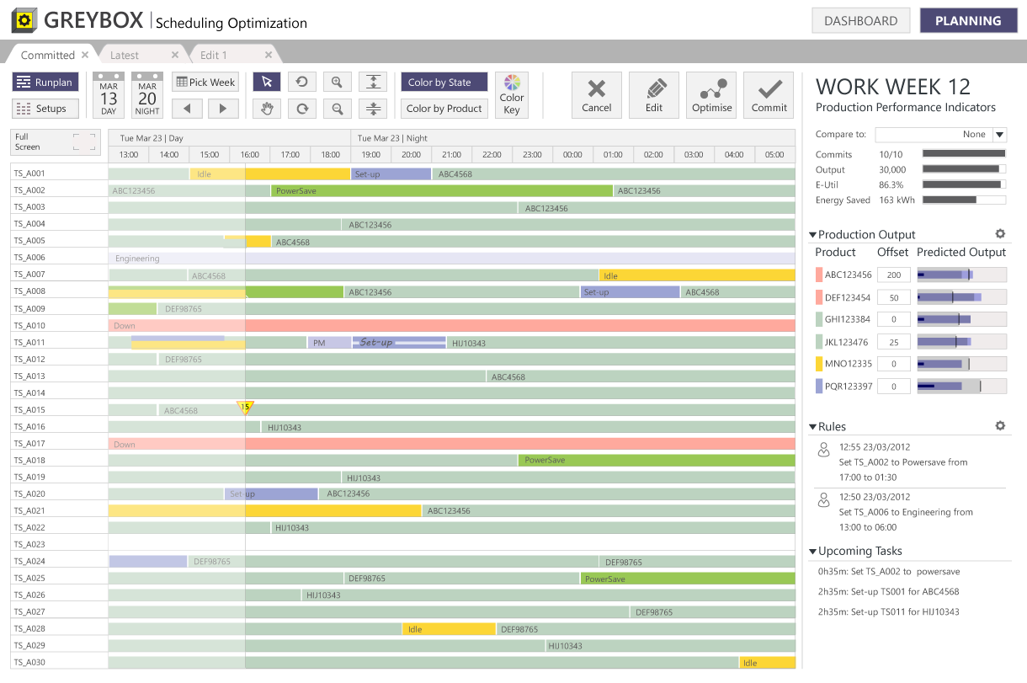
Figure 1 Planning Screen

Tabs
The tabs at the top of the screen represent different scheduling strategies that may be applied to the problem.
Committed Tab: This represents the current schedule that is being executed. This schedule has been inspected and approved by a human supervisor and will remain unchanged, regardless of system updates, until a supervisor commits a new plan. This is important to maintain consistency and to ensure that the human supervisor maintains situation awareness.
Latest Tab: This represents the latest schedule that has been suggested by the optimization engine based on the system goals, the current state of resources and output, and any dynamic constraints that a user may have introduced. The optimization engine can be configured to run at specific intervals based on how frequently system data is refreshed. Each time the optimization engine runs, a new schedule is provided in the latest tab. A user may approve the latest tab at any stage, transforming it to the committed schedule.
Edit Tab(s): These represent schedules that are based on an existing schedule where a user has made amendments and/or manually triggered an optimization. A user can generate a new edit tab by clicking the edit button on an existing plan and then make changes to targets, resource events and system goals. Again, a user may approve an edit tab to transform it into the committed schedule.

Toolbar
Each schedule has a toolbar at the top of the screen just below the tab. This toolbar consist of a series of buttons that control how the user interacts with the schedule which are divided into the following areas.
Figure 2 Planning Toolbar
View Controls: Two buttons labelled Runplan and Setups allows the user to change how the schedule is represented. These views are described in more detail later in this document.
Time Controls: This area has two icons that represent the start and end dates of the current schedule that is being show. The Pick Week button triggers a calendar control that allows the user to select a week to view in the schedule. This may be current or historic. The forward and back arrows allow a user to move the current view back or forward in 1 week increments.
Schedule Interactions: These 8 buttons control user interactions with the display.
When the cursor button is selected the user can drag activity states around in the time-line or can right click to change activity types.
When the pan button (the hand icon) is selected the user can pan the zoomed in view of the schedule forward and back without interacting with the activities.
The undo and redo buttons allow the user to undo or redo interactions that resulted in dynamic constraints. This interaction is explained in more detail in the runplan section of this document.
The increase row height and decrease row height buttons allow the user to change the vertical height of the schedule. This is useful where the number of resources pushes the schedule off the screen.
Color Controls: These controls provide a user with different perspectives on the schedule strategy.
The Color by State button colors each of the schedule activities by its planned state.
The Color by Product button colors the processing activities by their associated products.
The Color Key brings up a window that shows color assignments to states and products.
Schedule Controls: Four schedule control buttons are provided.
Cancel deletes an Edit tab schedule. This button is inactive for Committed and Latest Tabs.
Edit opens the schedule in the active view as an editable schedule in a new edit tab. This button is active on all Tabs.
Optimise runs the optimization engine on the schedule in the active view. This button is active in all tabs however pressing it in the Committed or Latest tab causes a new Edit tab to be opened that contains the optimized schedule. Pressing Optimise in an existing Edit tab causes the optimized result to be returned in the same tab.
Commit transforms the active view schedule into the current committed schedule. This button is active on all Tabs.

Schedule Information Panel
A schedule information panel is presented to the right of each schedule. This consist of a number of subpanels that show how the current schedule performs in terms of performance indicators and outputs as well as showing dynamic constraints that have been proposed for this schedule.
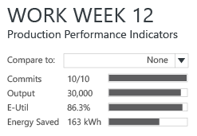
Figure 3 Performance Indicator Panel
The performance indicator panel shows the main indicators as both regular values and normalised values presented on a bar chart. These values are updated as the user interacts with the schedule thus showing the impact of schedule changes on the end of week goals. Below the panel header a “Compare to” drop down allows the user to make comparisons between current and edited or re-optimised schedules. This supports comparison of alternative schedules without the need to tab between views.

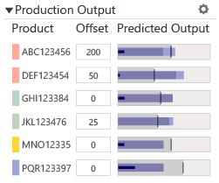  Figure 4 Output Panel | 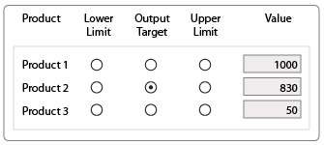  Figure 5 Output Configuration Panel
The output panel presents the volumes that will be output for each product by end of week using the current active schedule. This data is similar to that presented in the Dashboard output area and is again shown in the form of a normalized bullet graph (See description in dashboard section above). Each product also has an editable text field labelled Offset. The user can input values into this field that may not be present in the system data. For example, they may have excess inventory that was not shipped last week that can be included in this week’s output. Conversely they may need to hold back product that has not passed a quality inspection. The cog icon in the top right of this panel brings the user to an output configuration wizard where they can set the output target to a commit level or the upper or lower limits or to a user defined value.
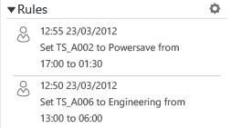
Figure 6 Rules Panel
The rules panel presents user-defined dynamic rules. The cog icon in this panel brings the user to a rules configuration wizard. Rules functionality is explained in more detail in Appendix 1 of this document.

Runplan – Resources View
The runplan provides a resources-centric view of a schedule across a week. A timeline occupies the horizontal axis while resources are shown as rows on the vertical axis. Resource states are shown as colored activity blocks over time. A vertical line in the display represents the current time. To the left of this line the tools historic states are shown under a semi-transparent panel. To the right of this line the future planned states are shown.
Figure 7 Runplan View
By default the planning view opens to the committed tab and the Runplan view in full-week mode. The user should review the committed plan and then access the latest tab to see the most up to date schedule proposed by the optimization engine. If the user is happy with the committed plan, they do not need to take any actions. If they prefer the proposed latest plan they should click on “Commit” to approve this as the committed plan. If they wish to make changes to either plan they should click “edit” to open a new edit tab.
On entering the manual edit mode, the schedule interactions region in the main toolbar becomes active. As the user rolls over activities in the schedule, the cursor changes to indicate move and re-size functionality. After editing any block the style of the font will change to indicate that this is a user defined rule, and the details of the rule will appear in the rules panel. The following editing functionality is currently supported.

Move an activity state
- Ensure the cursor button is selected in the toolbar then rollover the block you want to move.
- If the cursor changes to a 4 pointed arrow, click and drag the block forward or back in time
- N.B. only certain activity states can be moved. Refer to the table below.
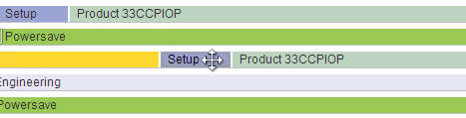
Figure 8 Moving an activity in time

Resize an activity state
- Ensure the cursor button is selected in the toolbar
- Rollover the handle at either end of the block you wish to resize
- When the cursor changes to a 2 pointed arrow, click and drag the handle forward or back in time
- N.B. only certain activity states can be resized. Refer to the table below.
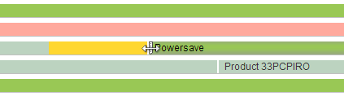
Figure 9 Resizing an activities duration

Change an activity state
- N.B. you can only ‘change’ non-interruptive activities i.e. processing, setup, engineering, pm
- Right click on the block to bring up the change context menu.
- Select the activity that you wish to change to
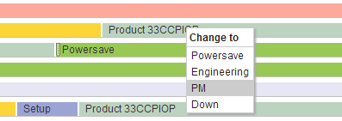
Figure 10 Changing an activity

Insert an activity state
- N.B. you can only ‘insert’ activities where the tool is ‘idle’ or ‘powersave’.
- Right click within an ‘idle’ or ‘powersave’ block on a resource to bring up the insert context menu.
- Select what you want to insert – Setup, Engineering, Powersave or Down.
- When the new activity block appears you may need to resize following the instructions above
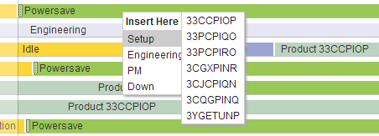
Figure 11 Inserting a new activity
Interactions are constrained based on the characteristics of a tool state and its adjacent tool states. These constraints are outlined in the table below. If the user makes a change to any tool state, a dynamic rule is generated and displayed in the rules panel. The impact of these changes on PPI’s will also be calculated and the PPI and Production Output panels will be updated accordingly.
Table 1 Interaction Constraints
Activity States | Resizable | Move Sooner | Move Later | Change to… | Insert… | Minimum Period
Processing | No | No | Yes | Yes* but not setup | No | na
Idle | No | No | No | No | Yes | na
PowerSave | Yes | No* | Yes | Yes | No | Yes
Set-up | No | No* | Yes | Yes | No | na
Engineering | Yes | No* | Yes | Yes | No | No
Down | Yes | No* | Yes | Yes | No | No
PM | No | No* | Yes | Yes | No | No
No*= unless adjoined by Idle or PowerSave
Yes*= unless already started
Changing Inserting or deleting a setup sets all future states of the tool to unknown indicated by crosshatch. Following editing a user can either commit, optimize, edit or cancel. Rules may also be introduced using the rules configuration option. See Appendix 1.
Any rules that are input by a user are considered to be dynamic constraints. If the systems configured to use an optimization engine these rules are passed to the optimization engine as fixed constraints. The optimization engine will generate new schedules that accommodate these user defined rules. Users may inspect, edit or delete any user defined rule at any time.

Use-case Scenarios
In order to explain how the system can be used in a real world scenario we provide a series of scenarios based on a manufacturing use-case. Each scenario poses a situation in a production line at a specific time within the production period. This is followed by an explanation on how the system may be used to resolve the situation using the GREYBOX system.

Scenario 1:
What: Updating the Schedule
Where: Tactical Operations Meeting
When: Tuesday 8:30am
Description: A range of updates are passed down at morning operations meeting. These include a request for engineering time on a tool, a request to pull in a Preventative Maintenance (PM) cycle and a reduced number of human resources (technicians) on the shift (reduced from three to 1). What are the implications of these changes for how the floor is set-up and run? What effects will these changes have on End of Week indicators (commits, output, utilization, energy saving)
Tasks:
- Open Application, move to Latest tab, inspect.
- If latest tab shows improvement then commit.
- Zoom in to current shift & click on edit
- Apply 6 hours of engineering time on specified tool at 10am
- Pull in a PM on specified tool by 8 hours
- Click on optimize
- Inspect optimized plan for overlapping Set-ups. As there will only be one technician available manually redistribute remaining set-ups to give sufficient time to carry them out.
- Compare PPI’s (Production Performance indicators) of this plan to committed plan.
- If indictors are satisfactory then commit this plan

Scenario 2:
What: Updating output targets
Where: Production Planning Meeting
When: Monday afternoon
Description: You are given an update on the goals for this week’s commits. This involves an increase in the target of priority 1 product by 1000 units. You must check that you can meet this new commit. You also get information that 800 units of priority 2 product will be released by quality control and are approved as output.
Tasks:
- Open Application, move to Latest tab, inspect.
- If latest tab shows improvement then commit.
- Increase lower limit for product 1 to from 2000 to 3000 units
- Run optimize. Result shows that product 1 will not be able to make this increased commit.
- Input that 800 units of priority 2 product will be released from quality control review (using offset)
- Re-run optimize. Results show that all commits can now be met.
- Compare PPI’s (Production Performance indicators) of this plan to committed plan.
- If indictors are satisfactory then commit this plan

Scenario 3:
What: Updating Engineering Requests
Where: Tactical Operations Meeting
When: Friday 8am
Description:
Due to some quality issues a series of engineering requests have been made for Friday. Bearing in mind that this is close to the shipment date you must accommodate this on a best effort basis. This means you should carry out as many engineering requests as possible without having a negative impact on commits.
Tasks:
- Open Application, move to Latest tab, inspect.
- If latest tab shows improvement then commit.
- The following request have been made
  - 9 hours on tool 325
  - 3 hours on tool 330
  - 6 hours on tool 321
  - 12 hours on tool 307
- Click on edit and input all requests
- Click optimize and inspect indicators
- As you are missing 2 commits, remove the 9 hour engineering
- Click optimize and inspect PPI’s
- As you are missing 1 commit, remove the 12 hour engineering
- Click optimize and inspect PPI’s
- All commits are met so commit this plan

Scenario 4:
What: Emergency Procedure
Where: operations command center
When: 2:15pm Friday
Description:
A Corporate Services incident results in power failure across the entire floor on a Friday at 2pm. It is estimated that this will take 9 hours to recover from. What are the implications for the plan? Can commits be met? How should the fleet be configured to meet all goals?
Tasks:
- Open Application, move to latest (this shows all tools down), commit latest.
- Click on edit
- Pull-in down state on all tools to 9 hours
- Optimize and inspect outputs
- How many product commits can you meet?

Appendix 1 - Rules Configuration
The rules panel keeps track of all dynamic rules defined by users. Each rule is shown as a list item of structured text. Clicking on the configure Icon (Cog) opens up a Rules manager window with the details of all rules. The icon toolbar at the bottom of the rules panel supports the following functionality.

New Rules can be generated either by A) interaction with the run-plan visualisations or B) Clicking on the new rule icon which opens the rules wizard.

Delete Rules by clicking on the delete icon.

Edit Rules by clicking on the edit icon.

Rules Wizard
The rules wizard allows a user to manually define a rule. This can support rules that are difficult to define using drag and drop functionality in the visualizations (e.g. multiple tools, products and recurrence.) All rules fall into two categories Equipment Rules or Product Rules. After defining the general rule type the user is provided with a series of drop-downs/inputs to define the rule. A recurrence checkbox allows a rule to be repeated over a user defined period.
The flow chart below shows the interactive process for rules configuration.

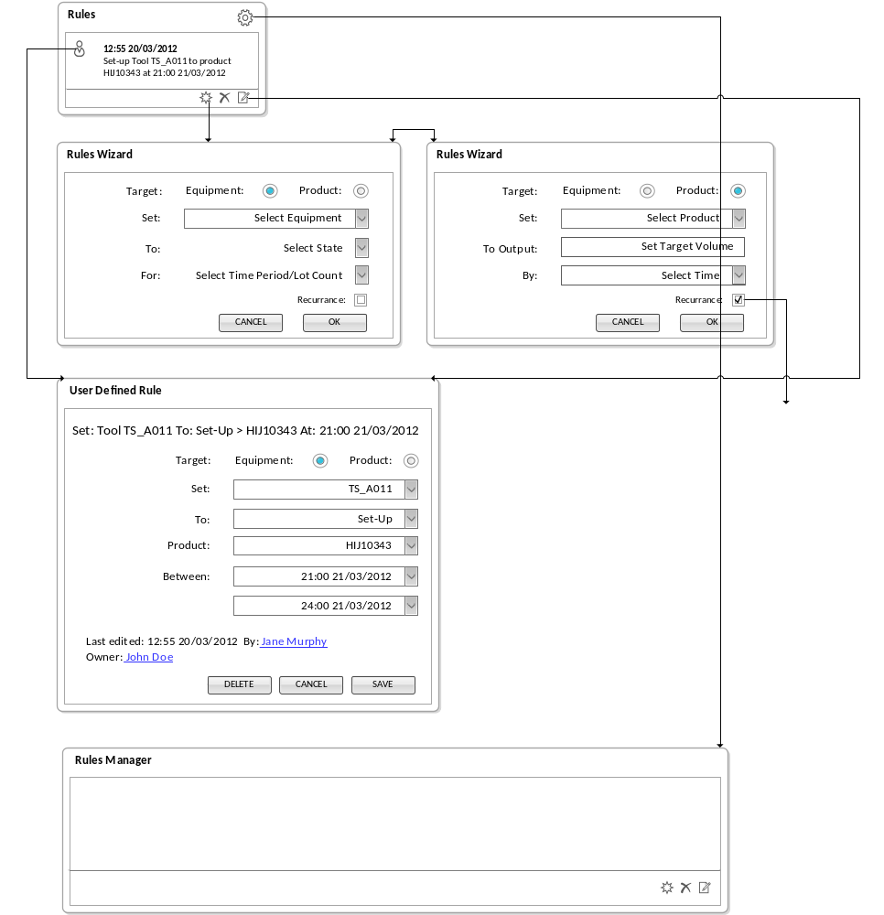

requires an optimization engine

